CMR Institute of Technology
Kandlakoya Village, Medchal Rd, Hyderabad, Telangana 501401
Institute Innovation cell
Developing Online Repository of Ideas Developed and Wayforward plan

Team Name : BIA (Brothers in arms)
Members:
1. 21R05A0411 ( BIYYALA VASUDEV )
2. 21R05A0412 ( KOLCHALMA SHEKAR )
Idea Title: Blind Guide
Problem Statement:
To detect obstacles on the road by blind person and to avoid them using alerts from then device

OVERVIEW
We are going to built a smart stick for blind people in this we are going to use uv sensor and flame sensor in this we are going to add a fire fighter so that he can survive in flames by use of fire fighter inbult in stick

GOALS/Objectives
- He can easly survive in fire accidents for 15 minutes
- He can use for free walking
SPECIFICATIONS
1. SIMPLE TO USE
2. BATTERY CHANGEABLE
3. LESS WEIGHT
4. LESS COST
5. FIRE FIGHTER
6. SIMPLE TO CARRY

MILESTONES

Ideation/Data collection
I went to a park to watch surroundings I saw a blind is trying to walk on the track so I tried to communicate to him he told his total story I went to my brother’s,friend’s and family members and discussed with them and they gave some ideas like do a poject using sensors and etc things for blind people
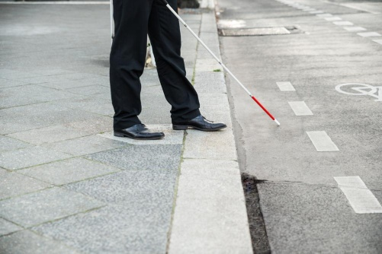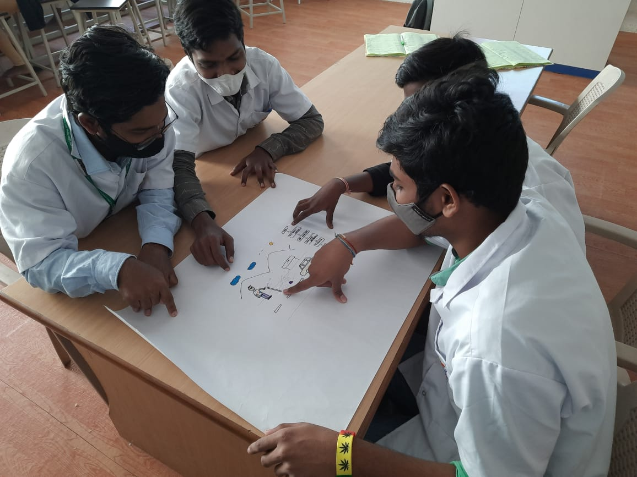

Fig 1: Problem scenario

Model Building
We are using ardiuno to connect to uv sensor and flame sensor on the stick and buzze for alerting user and also with vibrator for more alerting.

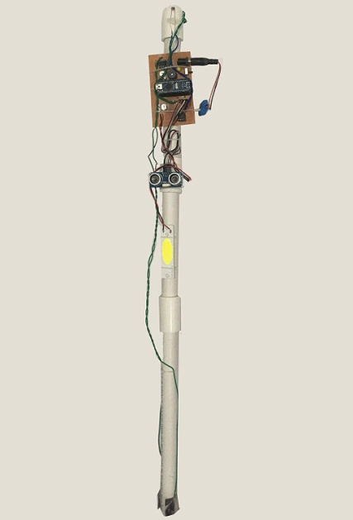
Fig 2 Model or blueprint

Components/Tools Understanding and usage
We are going to use arduino, uv sensor, flame sensor ,gas or water ,battery ,jumper wires and arduino ide software


Fig 3.1: Arduino software
This software is a free to use and easy to use for beginers and by use this software we can verify our code and dump in Arduino. we use this software to dump our code into ardiuino

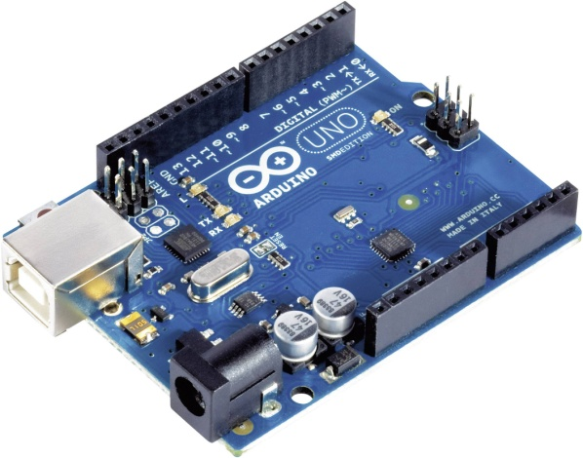
Fig 3.2 : Arduino uno
It is a device like a heart of the project without this we can’t use our project .In our project we are using arduino uno this is best for beginers and it is not wifi enabled in this project we are using this for run our project
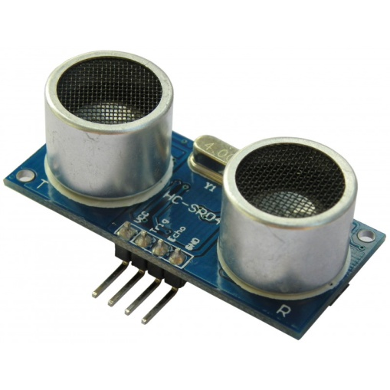
Fig 3.3: uv sensor
It is a device used to find the range and obstracles detection purpose .uv sensor is designed such a way it transmit’s and recieve’s by using echo signal .in this project we are using obstacle detection purpose
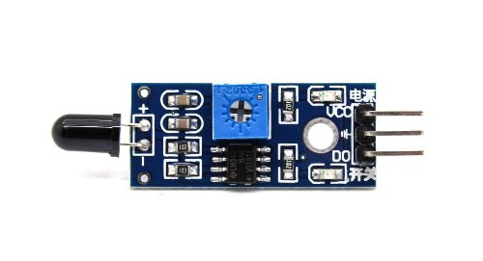
Fig 3.4: flame sensor
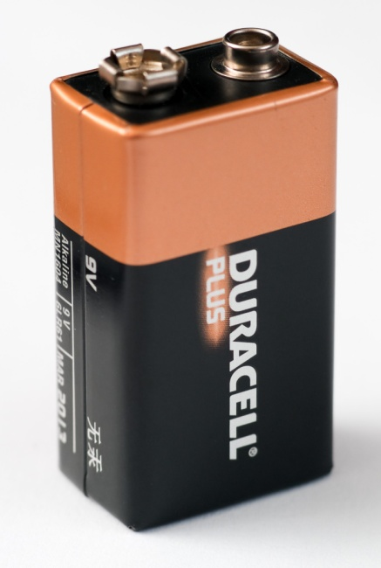
Fig 3.5: Battery
It is dc device which act as supply to the ckt . In this we us 9v dc battery which supply input to arduino uno
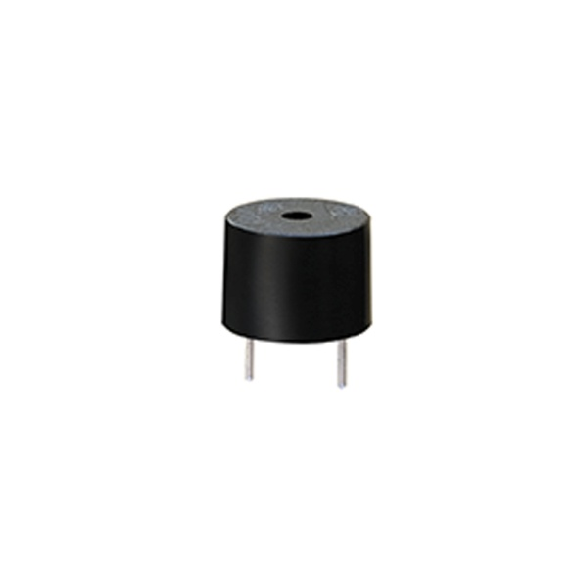
Fig 3.6: Dc buzzer
Buzzer is a device which make a sound for indication . we use dc buzzer in which we use for indication purpose

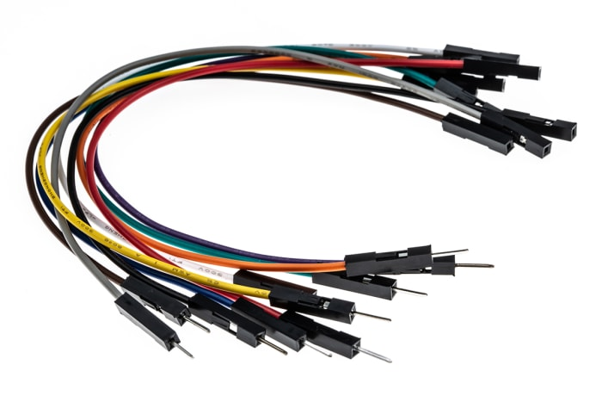
Fig 3.8: jumper wires
This jumper wires are three types 1.male to male
2.male to female
3.female to male
We use jumper wires for connection purpose instead of wires we use all three types of jumper wires in this project

